**LINUX COMMANDS LAB-1**

**NAME: V.TEJASWI ROLLNO:CB.EN.U4CSE19259**

**FILE COMMANDS**

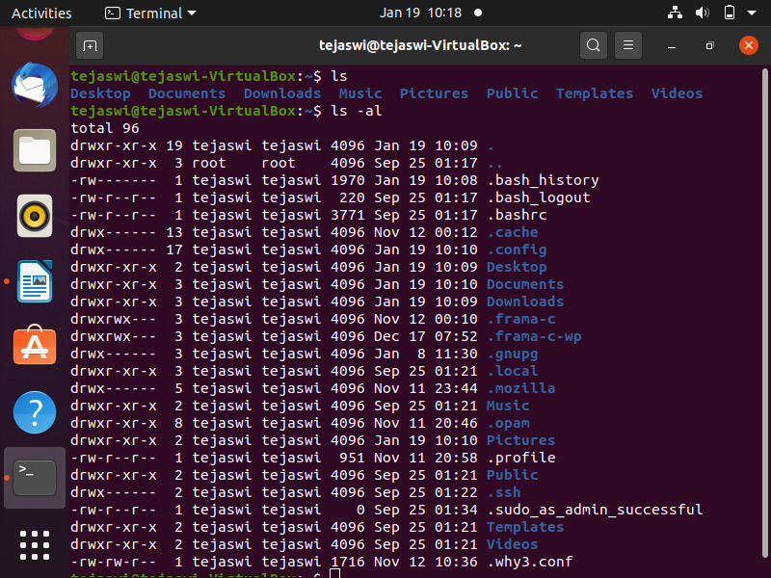

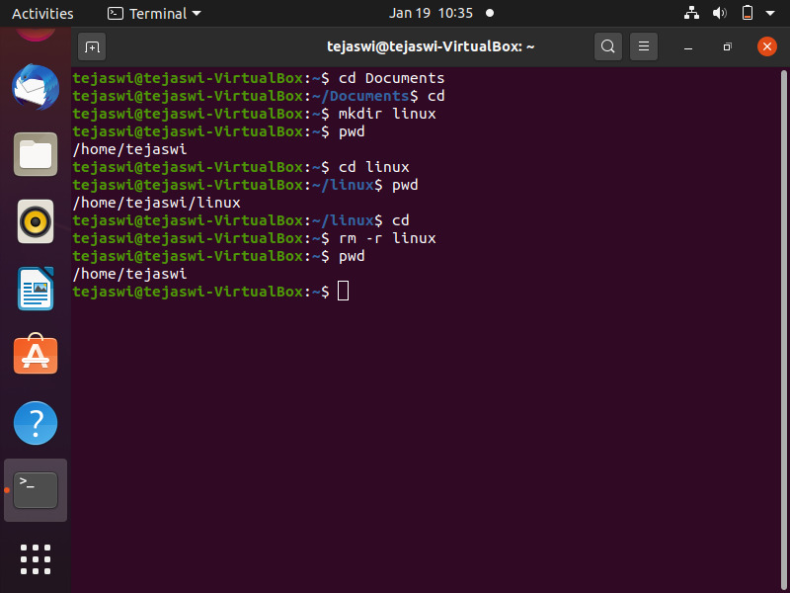

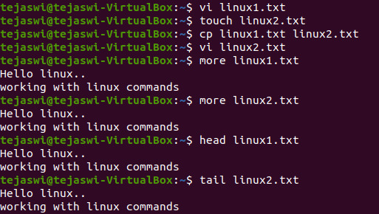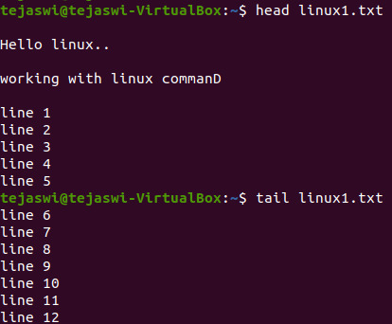

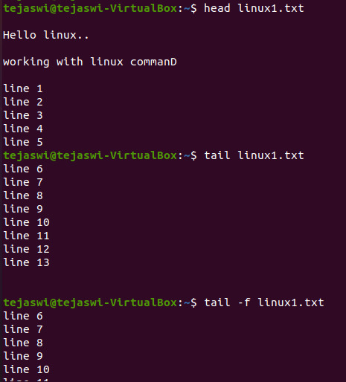

**PROCESS MANAGEMENT**

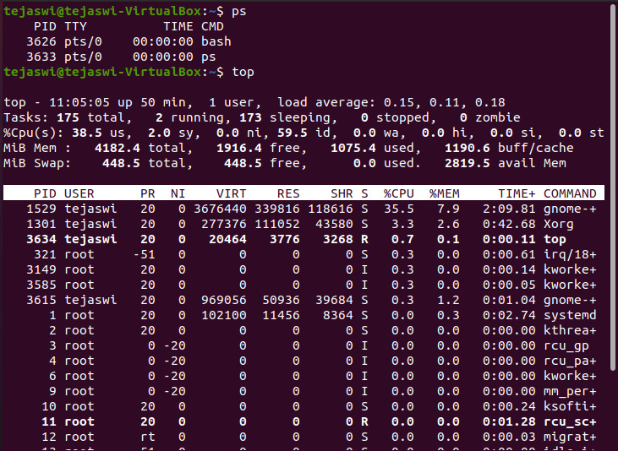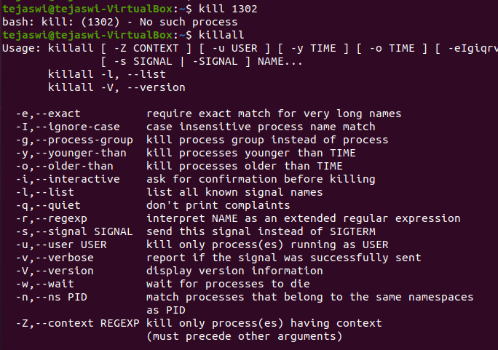

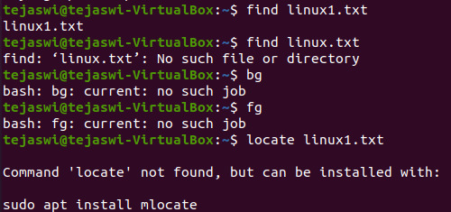

**SYSTEM INFO**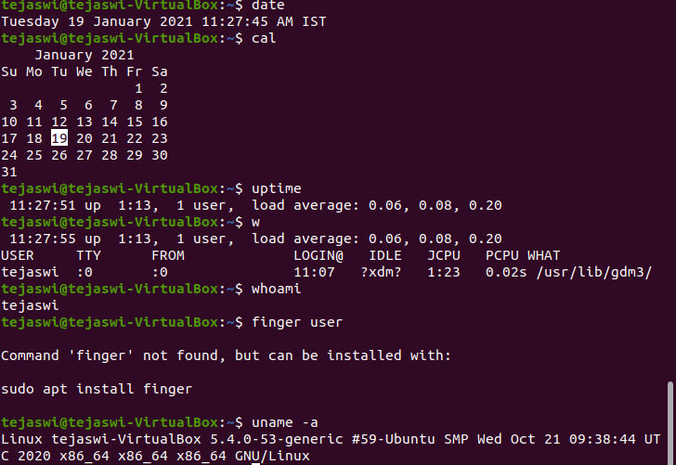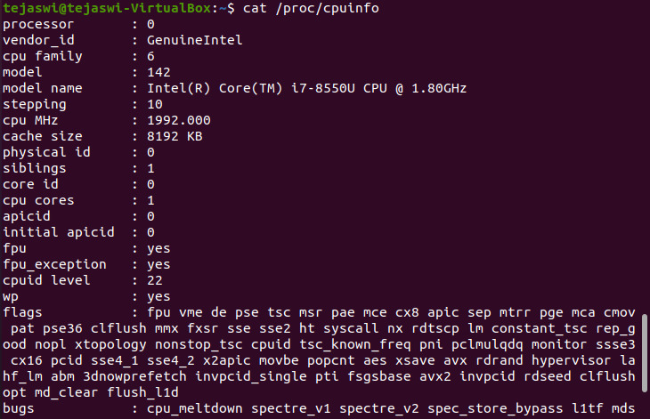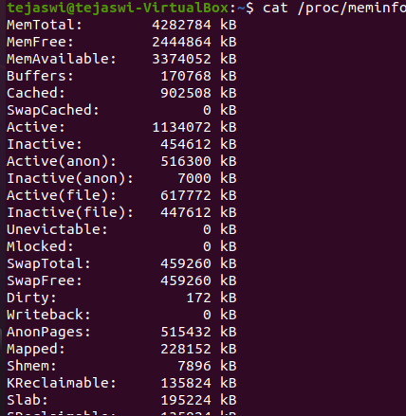

**MAN COMMAND**

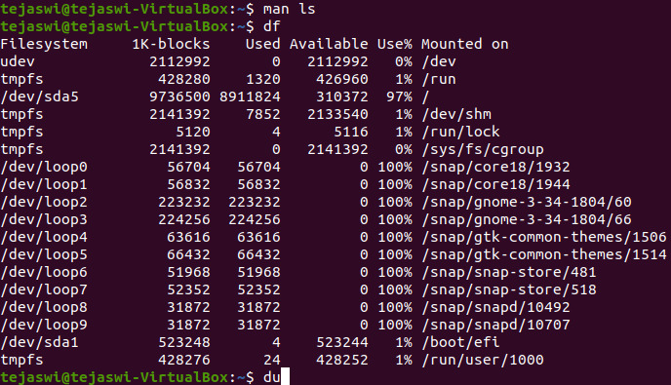

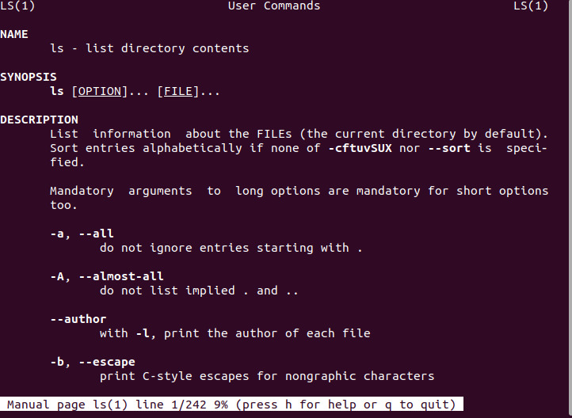

**SYSTEM INFO**

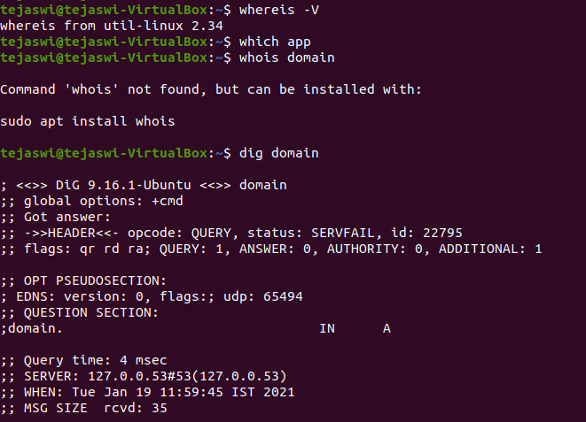

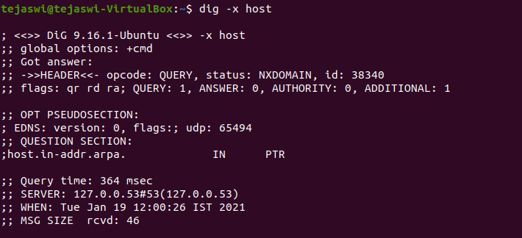

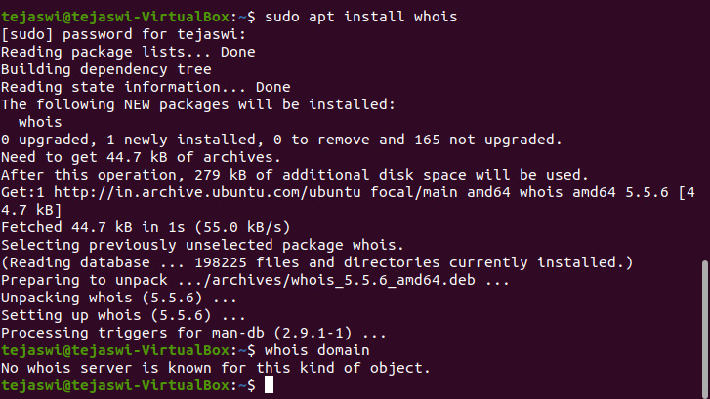

**SEARCHING -- GREP COMMAND**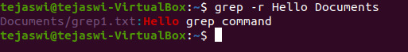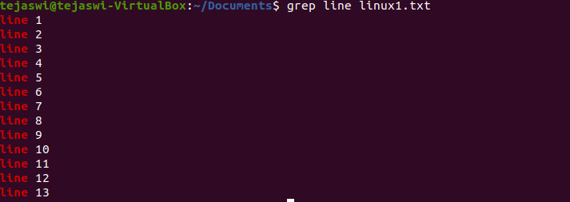

**COMPRESSION**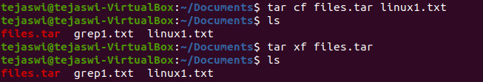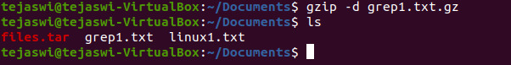

**INSTALLATION COMMAND**

**SSH**

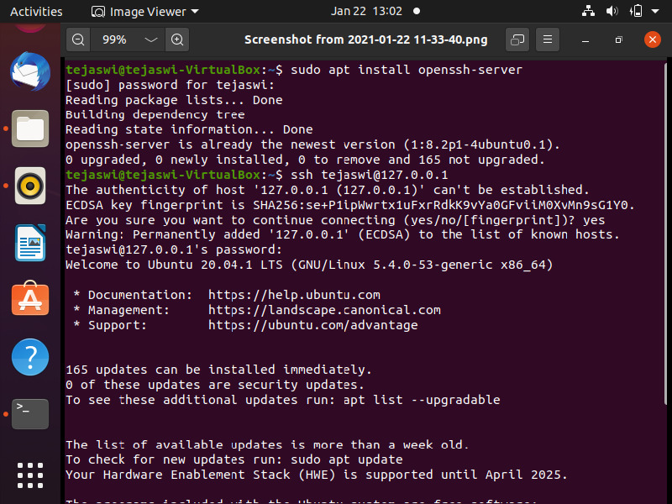

**SHORTCUT COMMANDS TRIED:** (counld’nt place screenshots of the shortcut commands)

1. !!- USED TO REPEAT THE PREVIOUS COMMAND WITHOUT TYPING THE COMMAND AGAIN
2. CTRL+D, EXIT- USED TO LOGOUT OF SESSION
3. CTRL+Z STOPS A COMMAND
4. CTRL+W- ERASES ONE WORD IN THE CURRENT COMMAND/SENTENCE
5. CTRL+U- ERASES WHOLE LINE

